停车场Parking lot
For Ren’s Wedding Proposal Scene (probably easier to do in a private parking rather than in a Service Area / Gas Station, so we can lock off and work properly at night)

1.停车场（船盛汽配城）——路程：5公里，12分钟。1. Parking lot（Chuan Sheng Auto Parts City）——Distance: 5 km, driving time: 12 minutes
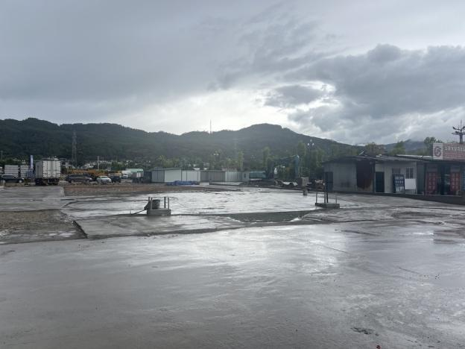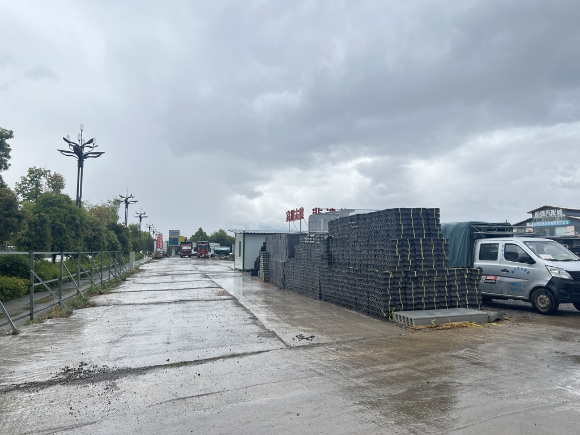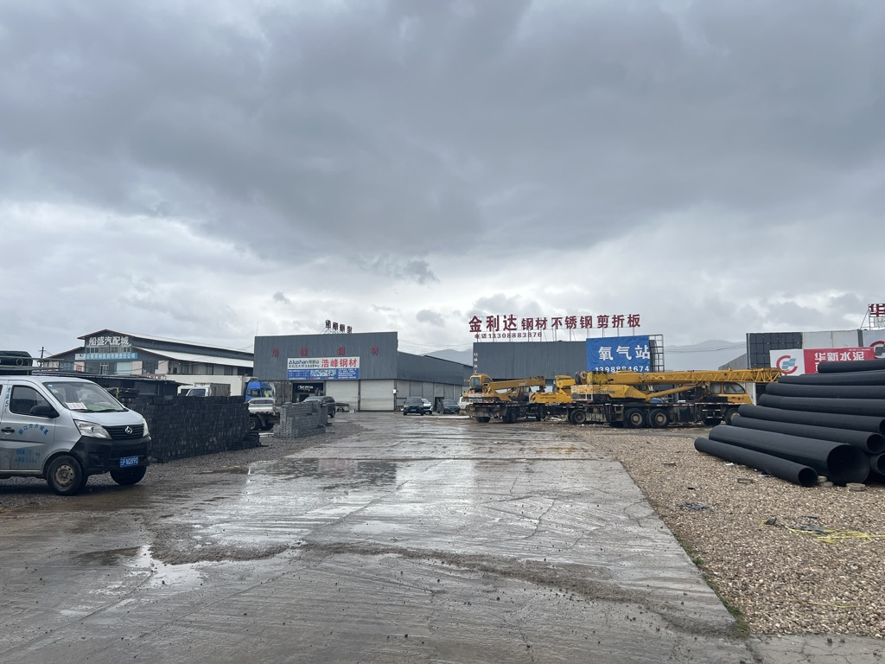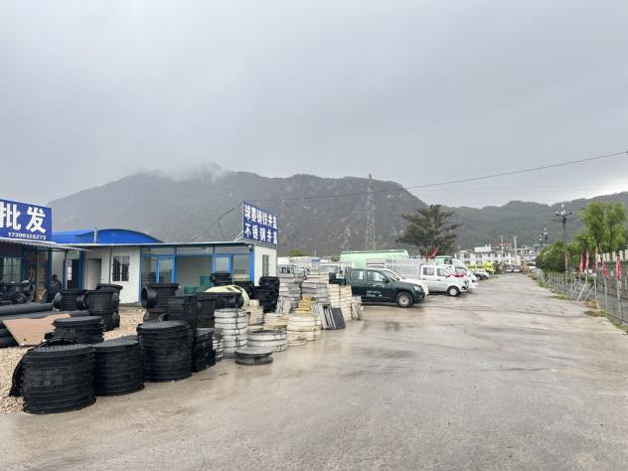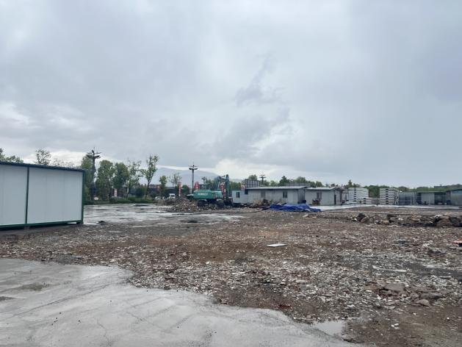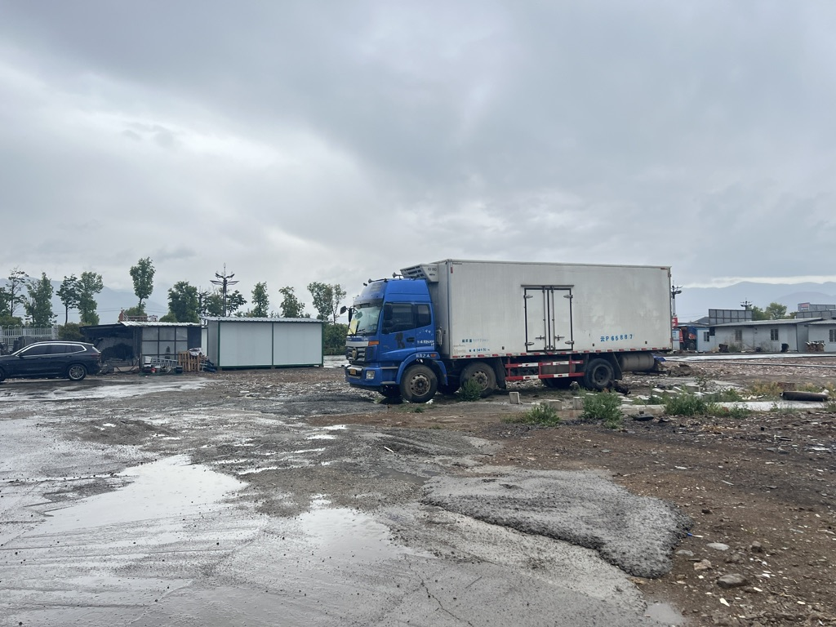
停车场车辆多，杂乱、无序。
The parking lot has many vehicles, which are messy and disorganized.

地点：丽江西West of Lijiang

2.停车场（宏文巷）——路程：路程：5公里，12分钟2. Parking Lot（Hongwen Lane）——Distance: 5 km, driving time: 12 minutes

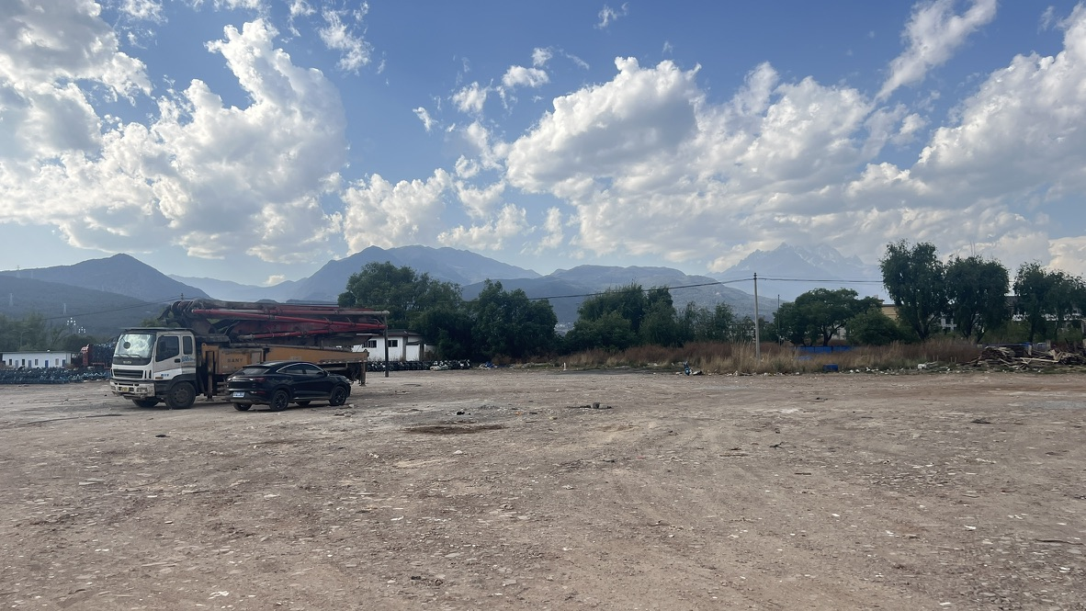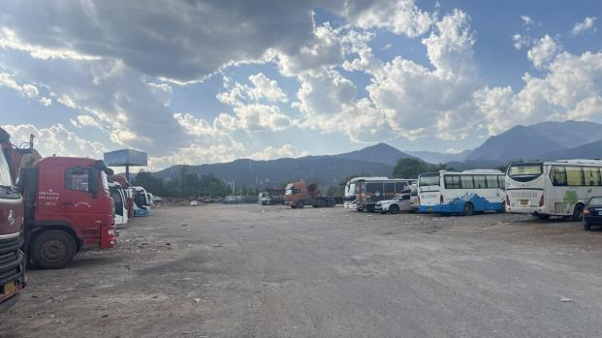
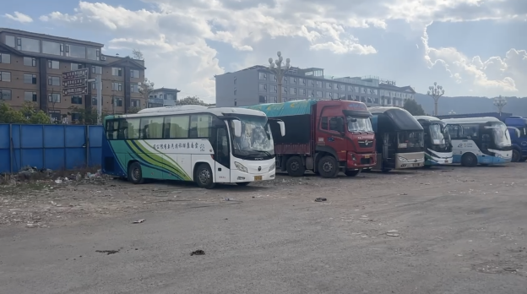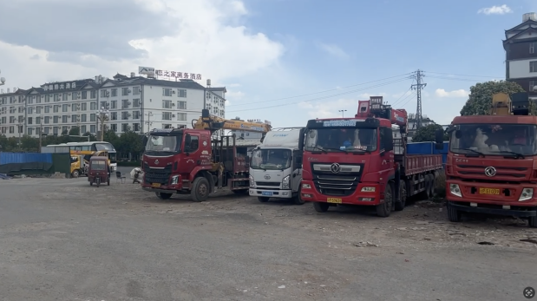
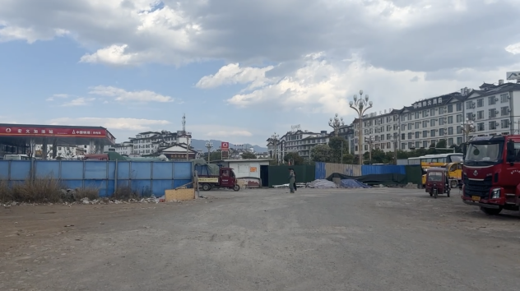
停车场挺大，但是周围建筑太多。The parking lot is quite large, but there are too many buildings around.

地点：丽江北Northern Lijiang

